Native Perennial Pollinator Seed Packets
Locally Grown and Harvested
Thank you for purchasing a Native Perennial Pollinator Plant Seed Packet from Sullivan County Conservation District. These seeds were grown in the SCCD Pollinator Garden - part of the Eco Ag Center at the Sullivan County Complex in Unity, NH. They were collected throughout the summer and fall, cleaned and overwintered, then packaged. This packaging is special, because students from Claremont Middle School designed the art on the front. To view more seed packet art, check out the gallery on our website: www.sccdnh.org and learn more about pollinators.

Why all the fuss about pollinators?
When a bumble bee feeds on the nectar and pollen of blueberry flowers, it pollinates the flowers, which will produce fruit eaten by songbirds, black bears, and dozens of other animals, including humans. We call the bumble bee and other pollinators keystone species because they are species upon which others depend. Pollinators are vital to maintaining healthy ecosystems. They are essential for plant reproduction, and produce genetic diversity in the plants they pollinate. The more diverse plants are, the better they can weather changes in the environment. Best of all, pollinators such as hummingbirds, bees, and butterflies are beautiful and fascinating.

Biologists fear several butterfly and bumblebee species have disappeared from parts of their range. It appears that habitat loss and pesticide poisoning account for much of the population declines. We can do our part to support pollinators by creating pollinator- friendly gardens and protecting wildlife habitat.

Why use native plants in your garden?
Pollinators are specially adapted to native plants, which are best adapted to the local growing season, climate, and soils. Most pollinators feed on specific plant species — hummingbirds sip nectar from long, tubular honeysuckle flowers, while green sweat bees prefer more open-faced sunflowers. Non-native plants may not provide pollinators with enough nectar or pollen, or may be inedible to butterfly or moth caterpillars.

Planting Your Seeds
Though these plants vary in their optimal needs of sunlight, moisture, and soil requirements, they successfully grow together on a well-drained site with full sun in Unity, NH. All the seeds have spent a minimum of 3 months in winter weather to get them ready for germination. Only one seed type needs to be scarified or scratched up before planting - Sundial Lupine. It is the largest seed in the pack, round, usually white, and there are only a few if any. You can use sandpaper to scratch it up a bit before planting.

What’s might be in this packet?
Seeds are shown life size. Seed links can be accessed on www.sccdnh.org under Plant Sale.
Yellow Wild Indigo, Baptisia tinctoria - Easily grown in average, dry to medium, well-drained soil in full sun to part shade. Tolerates drought and poor soils. Attracts butterflies and bees. seeds
Sundial Lupine, Lupinus perennis - Sun/part shade. Dry sandy soils. Blooms in June. This legume improves soil fertility through nitrogen fixation. This wildflower is the sole host plant for the rare Karner blue butterfly. Deer-proof. seeds
Broad Mountain Mint, Pycnanthemum muticum - Sun/part shade. Moist to dry soil. Bloom in summer. Attracts butterflies and bees. Provides soil stabilization. Deer and rabbit-proof.
Great Blue Lobelia, Lobelia siphilitica - Sun/part shade. Moist to wet soils. Blooms late summer. Attracts bees, hummingbirds, and butterflies. Deer proof. seeds
New England Aster, Symphyotrichum novae-angliae - Easily grown in average, medium, well-drained soil in full sun. Prefers moist, rich soils. Attracts butterflies and bees. Deep purple/pink flowers in fall. seeds
Golden Alexanders, Zizia aurea - full sun/part shade, moist to wet soils. Blooms late spring. The host plant for black swallowtail butterflies. Good for short-tongued insects. Long bloom time. seeds

Boneset, Eupatorium perfoliatum - Sun/part shade, moist to wet soil. Blooms late summer. Attracts butterflies and bees. seeds

Spotted Joe Pye Weed, Eutrochium maculatum - full sun, rich, moist soils. Attracts many butterflies. seeds
Cardinal Flower, Lobelia cardinalis - part sun, moist to wet soils. Blooms in fall. Bumblebees are the primary pollinators. seeds
White Turtlehead, Chelonia glabra -The Baltimore Checkerspot butterfly lays its eggs on the leaves. White to pink flowers. It likes moist soil and can tolerate shade. Bumblebees are the primary pollinators. Great for rain gardens. seeds
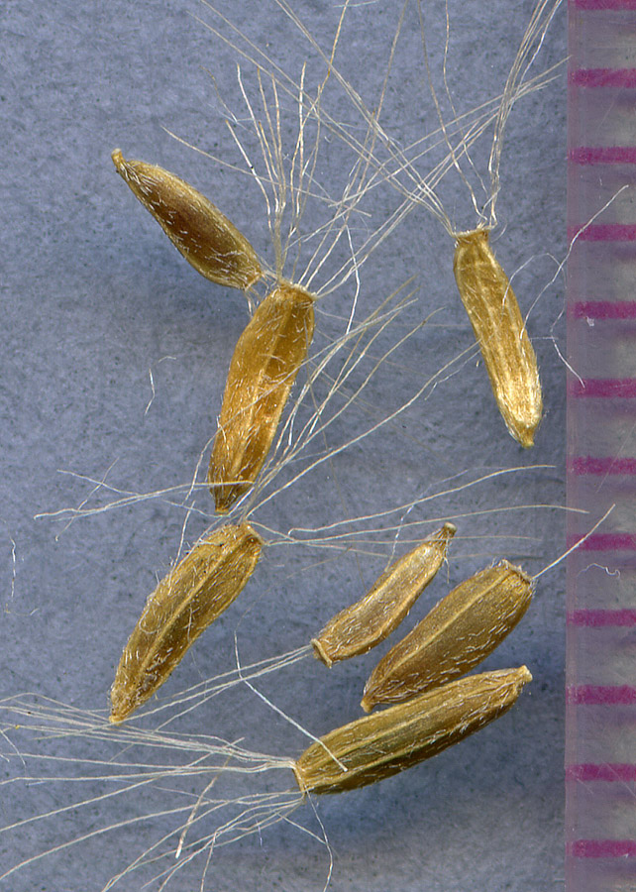
New England Groundsel, Packera schweinitziana - Sun/part shade, moist to wet soil. Blooms spring and summer. seeds
Northern Blazing Star, Liatris novae-angliae - Sun/part shade, moist to dry soils. Blooms in Summer. Endemic and rare in New England. Attracts butterflies and seeds are important food for birds. seeds
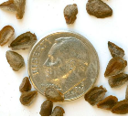
Butterfly Weed, Asclepias tuberosa – sunny, dry, well-drained soils. May take a year to get going. Orange blooms in summer, host plant to monarch butterfly. seeds

